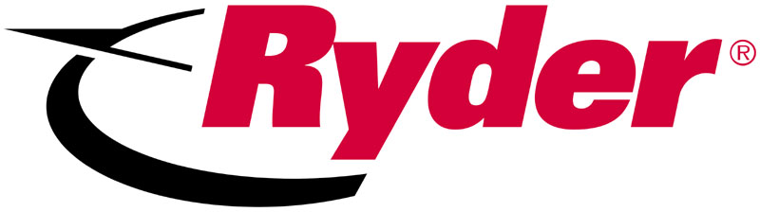
Vehicle Sales Inbound Call Sheet
Today’s Date __________________Who referred you? _____________________________________________
Purchase from Ryder Before? Yes No How did you hear about us? ___________________________
Customer Name _____________________________________________________________________________
Business Name _____________________________________________________________________________
Address ___________________________________________________________________________________
City _______________________________________ St. ______________ Zip ________________________
Phone ____________________________________ Fax _____________________________________________
E-Mail _____________________________________________________________________________________
Why are you looking to buy a vehicle_______________________________________ Date needed: __________
What is your monthly budget allowance _________ How are you Financing? _____________________________
What is it going to mean to you to buy the right truck from the right company?

Could you tell me about the truck application and about your business?

Is there anyone else going to need to be involved in making the equipment purchasing decision?
NO YES If Yes Who __________________________________

Can you tell me about some areas of your business impacted by transportation?
Need ______________________________ Why important ________________________________
Need ______________________________ Why important ________________________________

Is there anything else I should know about your business? ___________________________________

Feature __________ What it means to you is __________________________________________

Feature __________ What is means to you is __________________________________________
Recommendations made:

Sales Person _________________________________

F/U Date ______________ F/U Date ______________ F/U Date _____________

L 1 2 3 4 5 6 7 8 9 10 W

